**Amazon Business Approvals Enablement**

**To enable Amazon Business Approvals please follow the steps below:**

1. **Log in to your Amazon Business Account and click on your account information. You should see the screen below:**

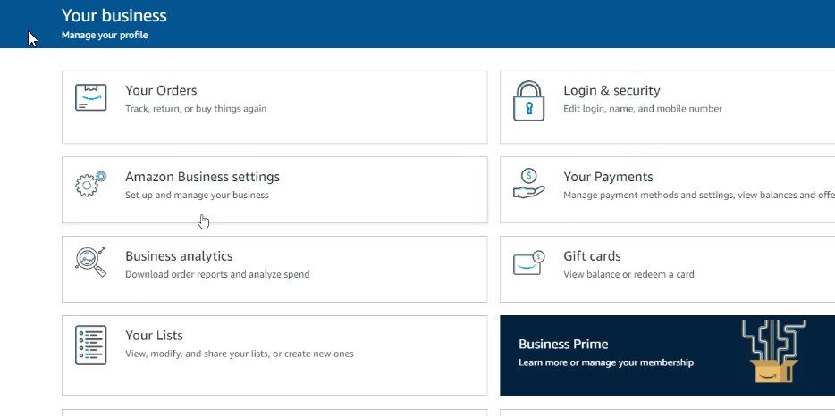

1. **Next, click on ‘Amazon Business Settings’. Then click on the ‘Buying Policies and Approvals’ option, found under ‘Buying policies.**

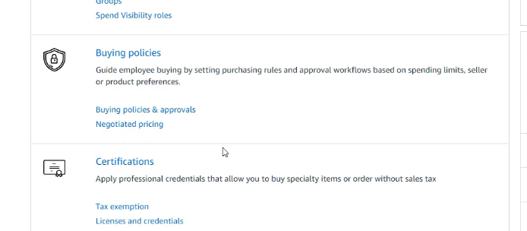

1. **Once in the ‘Buying policies and approvals’ page, click the ‘Approval Settings’ button located on the top, right hand side of the screen.**

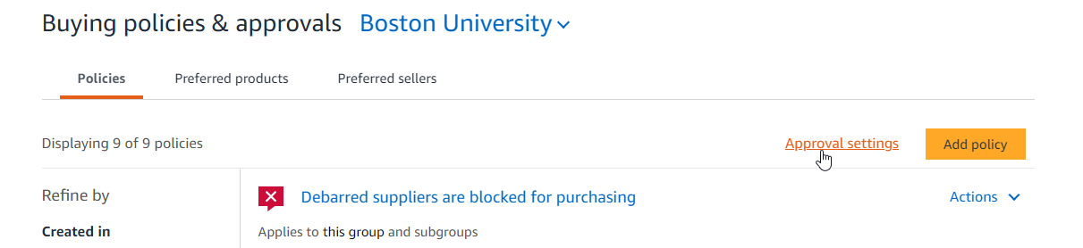

1. **Next, enter the email address of the department administrator or the individual who will approve the shipping address in the field ‘Boston University Approvers’, then click ‘save’. Note this person needs to be a user in Amazon.**

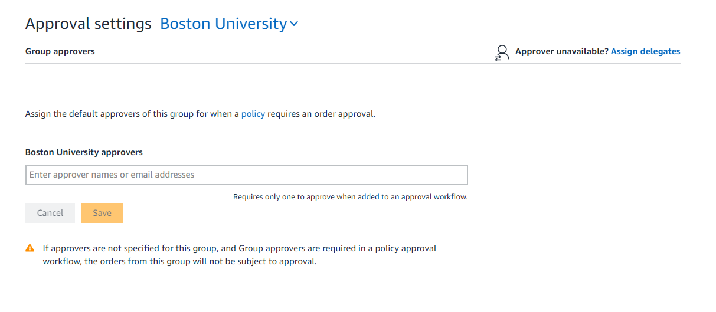

1. **There is a feature called ‘Temporary Delegates’ that allows department administrators to delegate the approval responsibility to an alternative member of their department in the event that they are not working on a particular day (sick day, vacation, leave of absence etc.).**

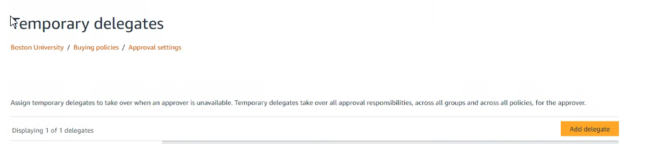

**5a. In order to enable this feature, select ‘add delegate’, then assign the approver role to the desired person for the desired date range. Please note this feature is intended for short term absences. The maximum date range to assign a delegate is one year.**

