STUDENT HOSTS INSTRUCTIONS MSE Talks - Seminar Series

OVERVIEW OF RESPONSIBILITIES
- Arrange visitors schedule for the day of colloquium, including meetings with individual faculty and a lunch meeting with a group of graduate students.
- Facilitate day-of logistics, including escorting the speaker to meetings with faculty if needed.
Notes:
- cc faculty host (your advisor) and Lea Sabra (leasabra@bu.edu) on all emails to the speaker and to the MSE office.
- See Email templates at the end of this document for most communication.

~3 WEEKS BEFORE THE EVENT
- Confirm how you will assist the Faculty Host (your advisor):
- Confirm the lunch preference with your advisor (faculty host): typically, you organize a group lunch with graduate students (see below), unless the faculty host wants to take the speaker out to lunch.
- Email the speaker, introduce yourself as their student host and ask
  - if they have specific faculty at BU in mind that they would like to meet with
  - if they have any restrictions throughout the day regarding meeting times
  - if they have dietary restrictions

2 WEEKS BEFORE THE EVENT
- Arrange the day-of schedule:
- Meetings: Arrange meetings for the speaker with BU faculty. These 1-to-1 meetings are typically ~25 minutes with 5 minutes to get to the next meeting (e.g., faculty meetings between 9 AM and noon, followed by lunch with students 12-1:30 PM, and again faculty meetings at 1:30 and 2 PM). If needed, a meeting can also be scheduled for 1 hour or after the seminar at 4:15 PM, but that is uncommon. For scheduling, it is easiest to use a shared google sheet with time slots indicated that faculty sign up for.
Follow this order to coordinate the time and location for each meeting:
    - Ask the faculty host (your advisor) when they want to meet with the speaker.
    - Individually and personally reach out to the to the faculty that the speaker indicated they would like to meet with, and any other faculty you advisor deems a good fit. Include speaker’s abstract and bio in your email, which can be found at https://www.bu.edu/eng/academics/departments-and-divisions/materials-science-engineering/news-2/msetalks/
    - Subsequently, if time slots are still available, reach out to all the MSE faculty: forward your message (see template below) to Lea Sabra (leasabra@bu.edu), who will send it on your behalf to materials-faculty@bu.edu. Make sure to include the available times, your email, or the link to the sign-up sheet (if you used it).
    - If you have trouble filling the meeting schedule (happens often), work with your advisor to reach out to relevant faculty directly (host faculty individually reaching out to other relevant faculty for meetings usually works well).
- Organize student group lunch:
- Typically, a group of graduate students will meet the speaker for lunch. To coordinate lunch plans and find MSE grad students for lunch, send message with abstract of talk, time of lunch and your email for RSVP to Lea Sabra (leasabra@bu.edu) to be forwarded to the MSE graduate students.
  - Option 1 (most common): Order pizza for on-campus meeting (preferred for large groups)
    - Reserve a room, often EMB 105 or EMB 121 (either through 25live or email Lea Sabra (leasabra@bu.edu))
    - Let Lea Sabra know what food to order, we typically do Otto’s Pizza.
    - If interest is beyond room capacity, MSE students have priority.
  - Option 2: Take speaker to a nearby restaurant (preferred BU Pub or Club):
- If you go to the BU Club or Pub, contact Lea Sabra (leasabra@bu.edu) to set up an ISR.
- If you go to a different restaurant, please pay with your own credit card. If that is a concern, let us know.
- Limit guest attendance to 5-7 guests (excluding the speaker).
- Collect the itemized lunch receipt.
- Make sure you do not tip twice (some restaurants include tip in the price).
- Show the tax exception certificate to the restaurant server before ordering (get from Elizabeth Flagg), you should not be charged tax.
- After the lunch, send the following to eflagg@bu.edu: itemized receipt, lunch guest list, and the address to which you want the reimbursement check to be mailed.

WEEK OF THE EVENT
- Monday/Tuesday before the event: Finalize the agenda using the template at the end of this document
  - Include meeting locations (building/room addresses).
  - Share with Lea Sabra (leasabra@bu.edu) and faculty host to review. They may provide edits.
- Tuesday/Wednesday before the event:
  - Send final agenda to EVERYONE involved (including the speaker and faculty meeting with the speaker).
- Offer to escort the speaker to their first meeting. You can meet them at the hotel and/or parking lot and bring them to the first meeting. Also, the student host typically escorts the speaker from meeting to meeting.

DAY OF VISIT
- Welcome the speaker in the morning
  - Escort speaker to the first meeting & bring a printed copy of the speaker schedule.
  - Escort the speaker to all subsequent meeting locations unless faculty offer to do so.
- 20 minutes before the lecture:
  - Check on colloquium room (EMB 105): Is the screen working? Is the food set-up?
- 15 mins before the lecture:
  - Help the speaker set-up their slide show.
- Concluding the visit
- Thank the visitor.
- If they ask about travel reimbursement, please tell them to forward their receipts to Lea Sabra (leasabra@bu.edu)

EMAIL TEMPLATES

Introduction email to Speaker:

Dear Dr. XXX,
I am the student host for your upcoming MSE Talks seminar at Boston University on MONTH/DAY/YEAR, I would like to thank you for your visit.

I am assisting the hosting professor, Prof. XXX in preparing for your visit. I’m available to help coordinate your meeting schedule and will serve as your day-of contact to answer any last-minute questions that come up and escort you to meetings.

To prepare for your visit, can you please answer a few questions?
- We will arrange meetings with BU faculty and students. Is there anyone in particular that you would like to meet?
- Do you have any time restrictions throughout the day of your visit?
- Do you have any dietary restrictions?
- Where would be best to meet for me to escort you to the first meeting location?
If you have any questions in regard to your visit, please do not hesitate to contact me. I look forward to meeting you and hosting your seminar.
Sincerely,
XXXXX
Student Host

Email to MSE faculty to create the day-of schedule:
Hello MSE faculty,
I am the student host for an upcoming MSE Talks seminar. On Friday, (insert month/day), Dr. XXXXX will visit from XXXXX. The talk title, abstract and a brief speaker bio is below.
Dr. XXXXX will be available [insert availability as meeting timeslots or link google sheet with prepared time slots that faculty can sign up for].
Please let me know if you would like to meet with Prof. XXX at one of the times listed here [or sign up for a meeting in the linked google sheet].
Thank you,
XXXXXX
Student Host
[Email]

{ADD EVENT DETAILS: name, title, university affiliation, short bio, talk title, talk abstract, which you can find on the event webpage: https://www.bu.edu/eng/academics/departments-and-divisions/materials-science-engineering/news-2/msetalks/}

Send the final schedule on the Tuesday/Wednesday before the event.
- Email speaker – use the template below and cc the faculty host and eflagg@bu.edu
- Email all people meeting with the speaker in a separate email – cc the faculty host, leasabra@bu.edu
Hello Dr. XXXXX,
A schedule for your upcoming visit to Boston University Division of Materials Science and Engineering on [date] is attached.

Do you have any questions or concerns about the schedule? Please let me know if I can make any adjustments.
Sincerely,
XXXXXX

Schedule of Prof. ??? – BU MSE Talks on ???
Time | Meeting/Activity | Location
9:00 – 9:25 am
9:30 – 9:55 am
10:00 – 10:25 am
10:30 – 10:55 am
11:00 – 11:25 am
11:30 – 11:55 am
12:00 – 1:30 pm | Lunch w/ Students | 15 St. Mary’s Street, EMB 121
1:30 – 1:55 pm
2:00 – 2:30 pm
2:40 – 3:00 pm | Seminar prep | 15 St. Mary’s Street, EMB 105
3:00 – 4:00 pm | Seminar | 15 St. Mary’s Street, EMB 105
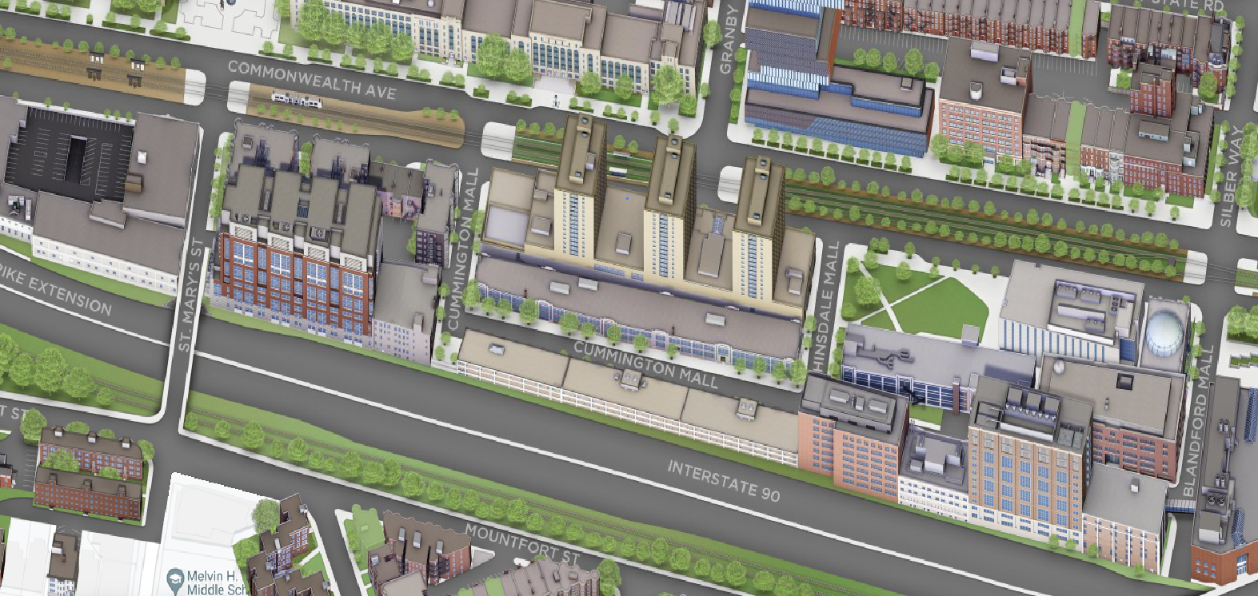
44 Cummington Mall
24 Cummington Mall
15 St. Mary’s Street
730 Commonwealth Ave.
590 Commonwealth Ave.
Photonics Center

